**Database System Practical 10**

**Table:**

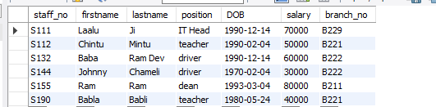

**Q1: Create a view so that manager at branch 200 can see only the details for staff who work in his/her branch office.**

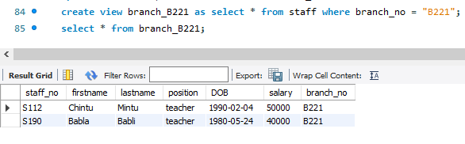

**Q2: Create a view staffdetails_B221 that excludes salary info so that only managers can access the salary details for the staff who work at their branch.**

